Barranquilla, May 13, 2026

CAPTAIN
NEWYORKER 620N
Booking 270711823
MAERSK
City

REF: TEMPERATURE CONFIRMATION

We are informating to you that the container (s) of TIERRA PROMETIDA TRADING S.A.S. Number MNBU4355023 to be discharged on PORT and Containing TAHITI LIMES.

Should have the temperature of:

“To Protect of the heat and the humidity “
Temperature: +8°C / 46.4 °F
Humidity: 90%
Ventilation: CBM/h 25%

Thanks for your attention,

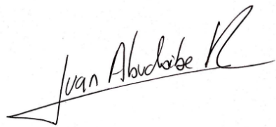
Best regards,

_____________________
Juan Alberto Abuchaibe Raheb

